**Background**

* I worked in the logistics company management team and found a more efficient way.
* Main purpose of management team is ‘Reporting to help your superiors make decisions.’ And the more efficient the way to get to this, the more profitable it will be for the company.

**What if I’m the president of the company?**

* I would want to know at a glance how much money went to a company and how much money I got from a company. In addition, if there is any data that I want to see, I want to see it in more detail right away.

**My final report included each of the following:**

Vendor Count

* Total number of Vendors
* Total number of AR/PR count

Monthly Analysis

* Total AR/PR amount per vendor

**Problem of the previous method**

* Logistics company has its own program (called Cello system) to store data.
* Cello system is only good for storing data. Extracting data is time consuming.
* The biggest part of the AR/PR system is to keep the company’s books straight. But this work requires a lot of time.

**Previous method**

A 🡪 Bellow picture shows the company’s bank statement.

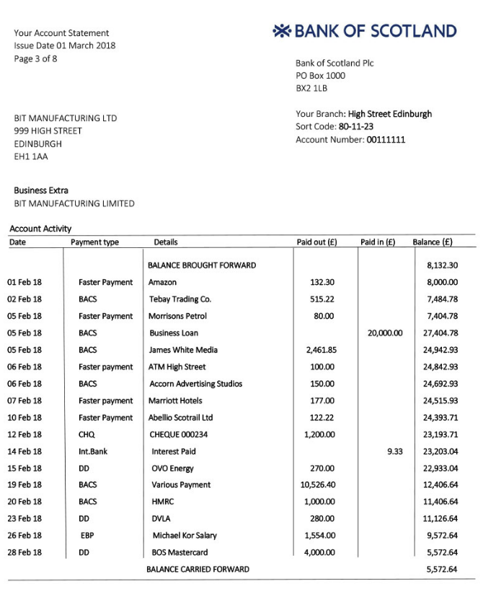

As it appears, there are AR/PR date, payment type, vendor’s name, and amount.

They transfer this information to the excel file everyday and report it to the boss.

B 🡪 The company stores same information into Cello system manually (There is no photos due to the company’s security concerns. However, it is the same as the above information).

C 🡪 AR/PR paper is generated for each line and stored in a folder by vendor name. AR/PR will be settled in the Cello system and will be stored in a separate folder.

They print the bank statement at the end of the month to make sure it matches the information in the Cello system. Then they highlight each line of the statement and mark AR/PR paper. This work takes a lot of time.

**My proposal**

* The basic theory of mathematics, if A=B and B=C, then A=C will be introduced.

Company generates AR/AP everyday and store them in a folder. In reality, their orders are not consistent with bank statements.

Assume that bank statement = A, Cello statement = B, and AR/AP paper = C.

As I mentioned above, they transfer bank statement info to the excel file. I would import this file to SQL database.

SQL table

The above picture shows the value of the bank statement imported into the SQL table and then extracted the result value. In reality, thousands of rows will be generated.

Then, we can say SQL table is ‘A’.

In order to keep the company’s books straight, we must confirm A is equal to C. B and C is always equal because company takes care of AR/AP right away and the values are directly stored in B.

However, the AR/AP paper is kept on file by vendor name, while the bank statement values are generated sequentially, so the value of C is distributed and written in A. Previously, it was done manually to check for matching, but now it can be easily solved through SQL database.

--Below is a SQL code for monthly analysis--

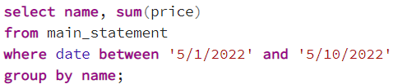

The result is

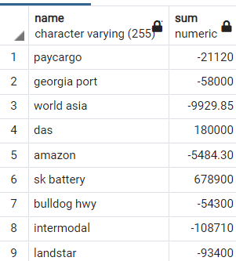

If we can confirm that B (Cello statement) matches the above value, then A is equal to B.

Because A = B and B = C, then A = C. The work is completed.

--Code for transaction count per vendor—

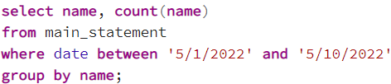

The result is

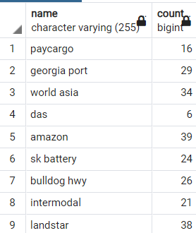

There were 16 transactions for Paycargo,

29 for Georgia Port,

34 for World Asia,

.

.

.

Between 5/1/2022 and 5/10/2022.

Conclusion

* The previous way takes too long. In other words, it takes a lot of workforce.

The company must constantly seek ways to reduce its workforce.

The more efficient the way to get to this, the more profitable it will be for the company.